Do you want to become part of the TECHNOLOGY REVOLUTION?

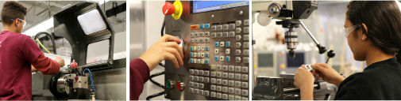Train to be a CNC Operator

**May 20th – August 23rd, 2019**

**INFORMATION SESSIONS:**

**Weds. , April 17 @ 9 a.m.**

**Friday, April 26th @ 9 a.m.**

***Location:*** MassHire Merrimack Valley Career Center, 255 Essex Street, Lawrence

**Monday – Friday (7:00 am – 3:30 pm)**

1. FOUNDATIONAL CLASSES: 4 Weeks @ NECC, Haverhill

*May 20 – June 14*

1. CNC CLASSES: @ Greater Lawrence Tech School, Andover *or*  Whittier Regional Vocational School, Haverhill

*June 17 – August 23*

Average starting salary $17/hour!

Bright Outlook  will grow within next 7 years! 100+ Machining companies in the Merrimack Valley! Earn a nationally-recognized Certificate!

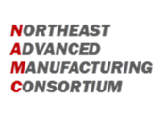

ELIGIBILITY:

FREE for ages 17-29 | CORI Check | HS Diploma or HiSET

Legally Eligible to Work in U.S. | Unemployed or Underemployed



**For More Information Call TODAY!**

Lisa Remington | (978) 722-7005 | [lremington@masshiremvcc.com](mailto:lremington@masshiremvcc.com)

MassHire Merrimack Valley Career Center, Lawrence

*OR*

Kimberly Jones | (978) 556-3067 | [kjones@necc.mass.edu](mailto:kjones@necc.mass.edu)

Northern Essex Community College, Haverhill